Jack Johnson

September 6, 2021

Section End Project: Call Record Analysis

Link to my GitHub repository: <https://github.com/jjohn98/2058519_Jack_Johnson_Mean_Stack>

This project is located in ~/Phase3/Call Record Analysis.

For this project, I simply ran a command to import the contents of call_data.json into a database and collection. This command uses MongoDB’s Database Tools, which are free to download and install from their website! With this, only one command is required for this process:

mongoimport --jsonArray -d callrecordanalysis -c call_log C:\Users\elipwns7\AppData\Roaming\SPB_Data\MEAN_Stack_TCS_July_2021_Batch\call_data.json

In this command, the –d and –c represent your database and collection you wish to import the data into. --jsonArray signifies that this is a JSON array. Finally, the end is the path to the file.

This is by far the easiest way to import all of the data dynamically!

The files for this project will be in the GitHub repository, as well as the source code section of the submission on Simplilearn.

**Screenshots of Commands and Database Verification:**

**Running the command:**

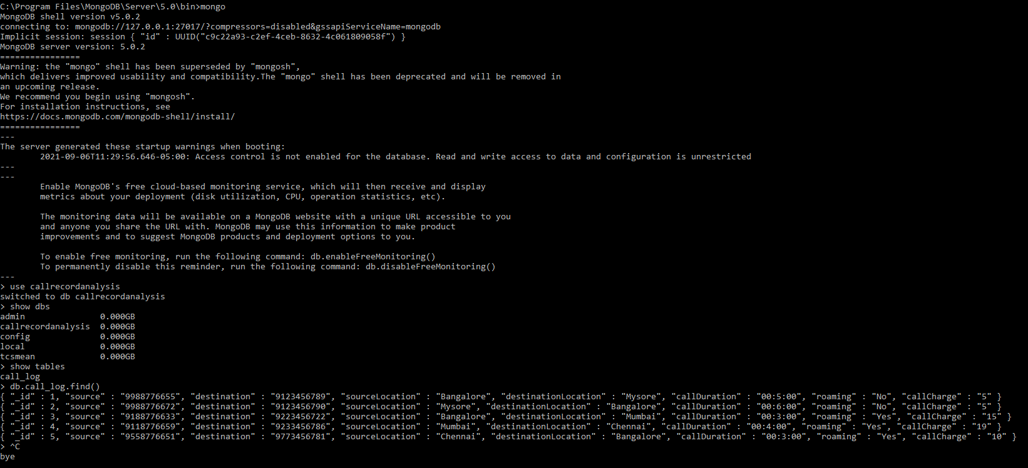**Checking the database and collection to make sure the data is present:**